**PRABAL GHOSH ROLL- AM.SC.P2CSC20040**

**SEMANTIC WEB –SPARQL ASSIGNMNET**

Assignment SPARQL

Create owl file to describe the following using Protégé:

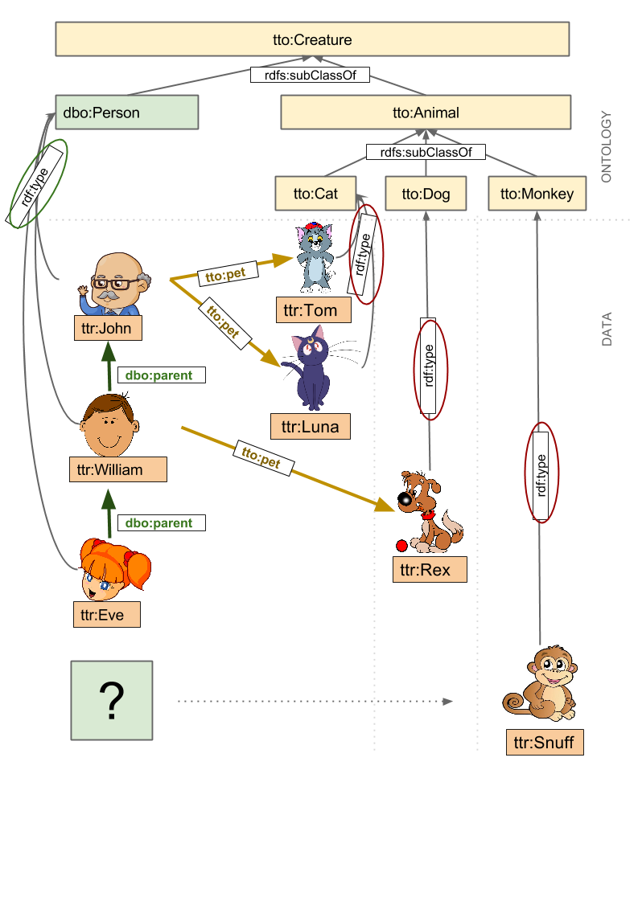

1.

Run the queries in protege for the questions given in the site https://sparql

playground.sib.swiss/ numbered - 200 till 209 using the owl file you have created. Then

try to run 220 (by filling in the *** blanks). Take a screenshot of the SPARQL code box

& the output and paste it in a word file for each question. (1.1 to 1.11)

2.

Write a SPARQL statement to find out: How many triplets are contained in the

dataset? Take a screenshot of the SPARQL code box and the output and paste in the

word file.

3.

Write a SPARQL statement to find out: How many instances of a “Animal” class are

declared? Take a screenshot of the SPARQL code box and the output and paste

below.

**SOLUTION:**

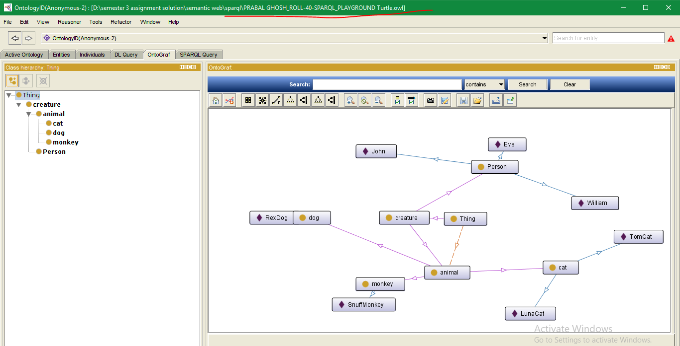

**1>**

**PREFIX rdf: <http://www.w3.org/1999/02/22-rdf-syntax-ns#>**

**prefix dbo: <http://dbpedia.org/ontology/>**

**prefix dbp: <http://dbpedia.org/property/>**

**prefix dbpedia: <http://dbpedia.org/resource/>**

**prefix tto: <http://example.org/tuto/ontology#>**

**PREFIX owl: <http://www.w3.org/2002/07/owl#>**

**prefix ttr: <http://example.org/tuto/resource#>**

**PREFIX xsd: <http://www.w3.org/2001/XMLSchema#>**

**PREFIX rdfs: <http://www.w3.org/2000/01/rdf-schema#>**

**SELECT DISTINCT * WHERE {**

**?s ?p ?o**

**} LIMIT 10**

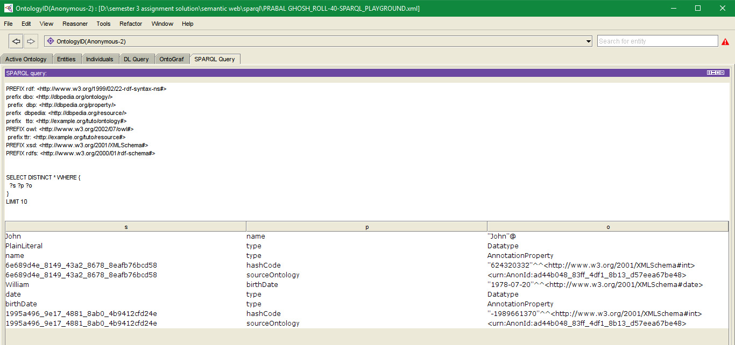

**200)**

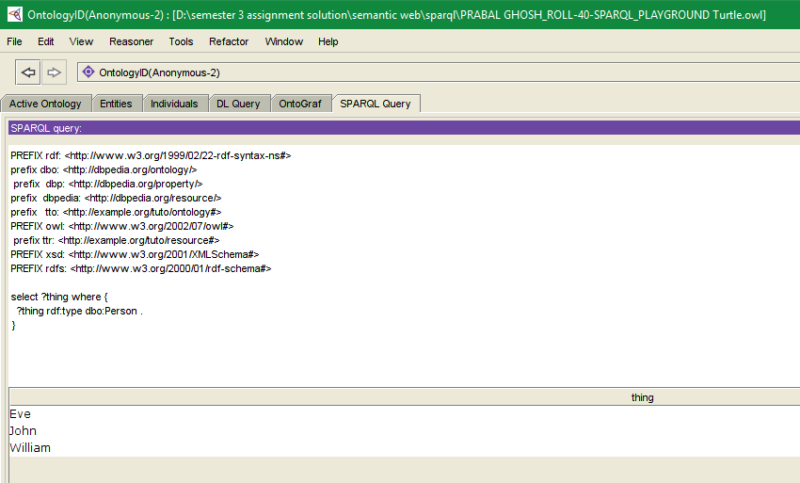

201)

PREFIX rdf: <http://www.w3.org/1999/02/22-rdf-syntax-ns#>

prefix dbo: <http://dbpedia.org/ontology/>

prefix dbp: <http://dbpedia.org/property/>

prefix dbpedia: <http://dbpedia.org/resource/>

prefix tto: <http://example.org/tuto/ontology#>

PREFIX owl: <http://www.w3.org/2002/07/owl#>

prefix ttr: <http://example.org/tuto/resource#>

PREFIX xsd: <http://www.w3.org/2001/XMLSchema#>

PREFIX rdfs: <http://www.w3.org/2000/01/rdf-schema#>

SELECT distinct ?s ?x

WHERE{ ?s rdf:type

owl:NamedIndividual ;

tto:sex ?x

}

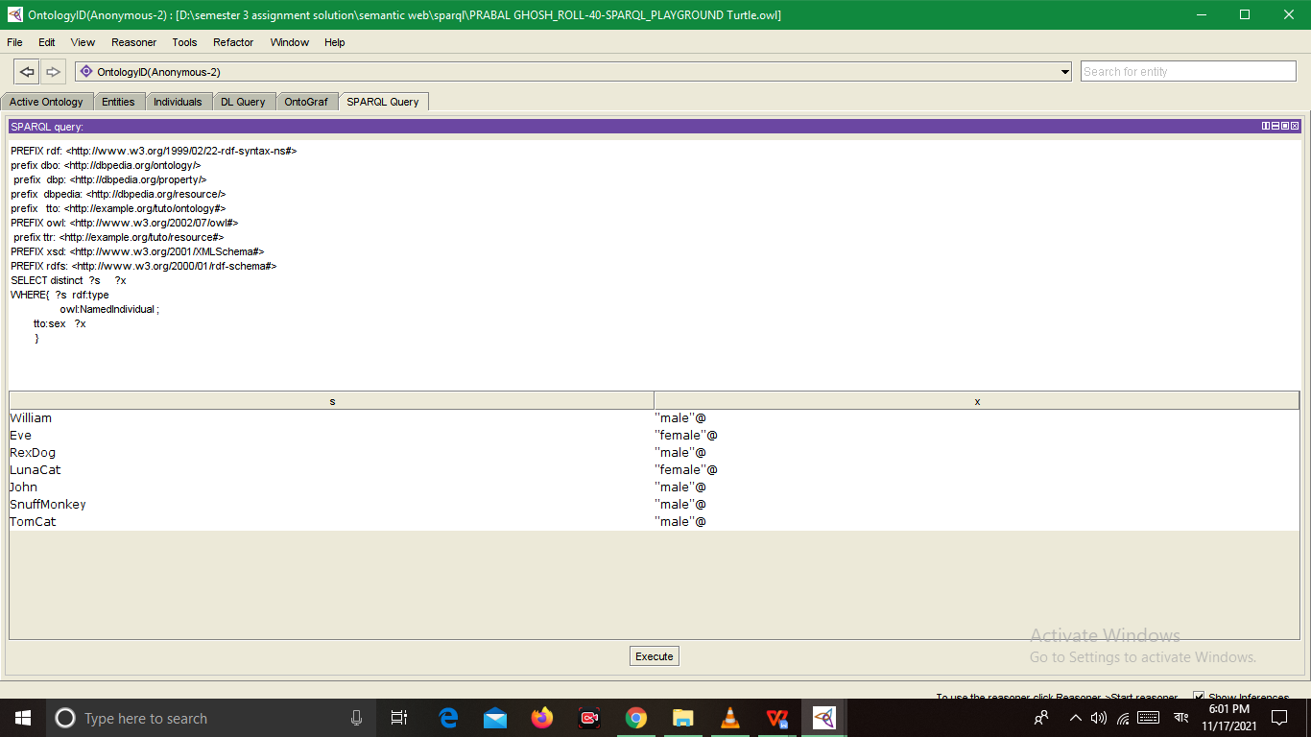

202)

select ?s ?x where {

?s a dbo:Person ;

tto:sex ?x

}

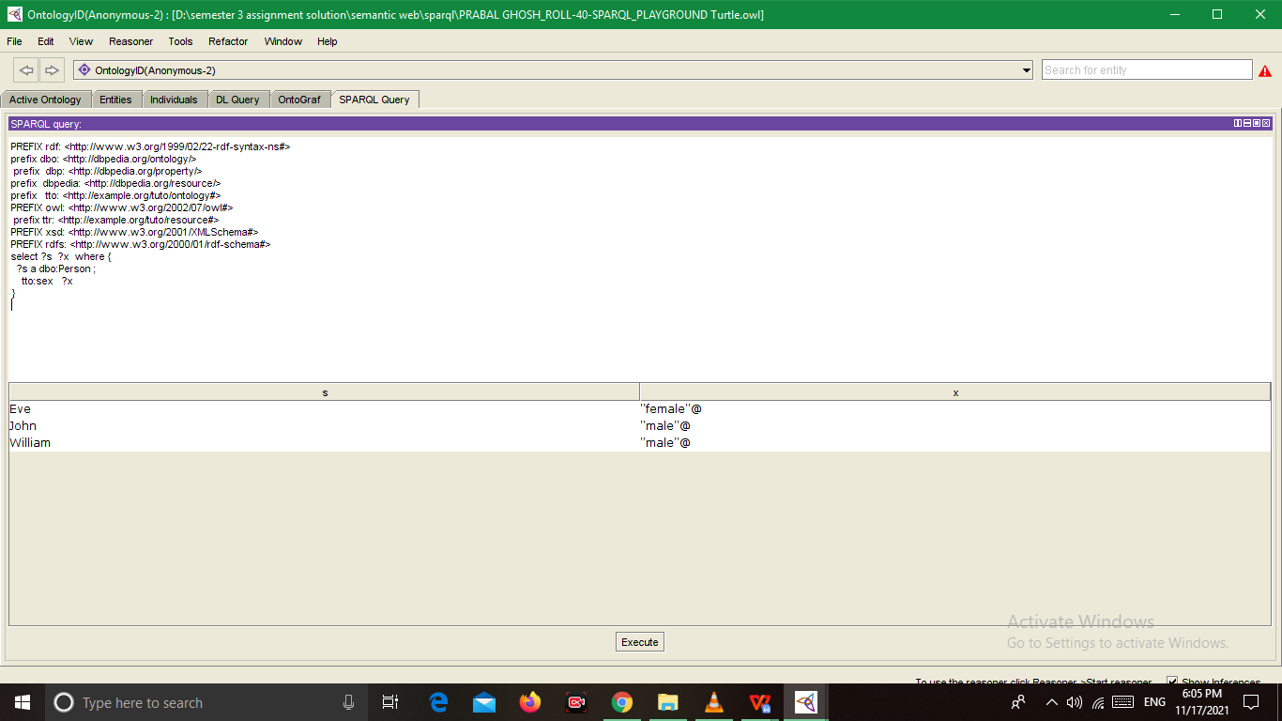

204)

select ?thing ?sex where {

?thing tto:sex ?sex .

}

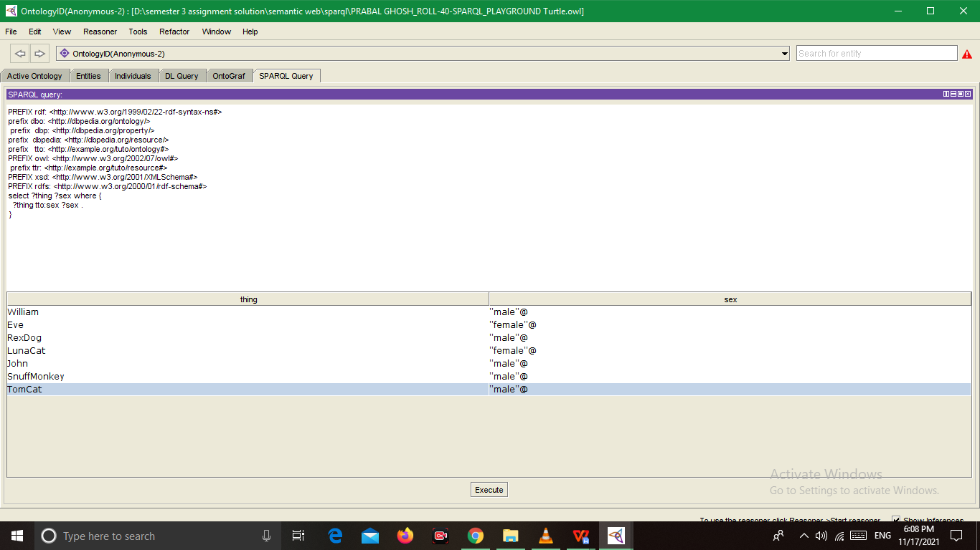

206)

select ?person ?pet where {

?person rdf:type dbo:Person ;

tto:pet ?pet .

}

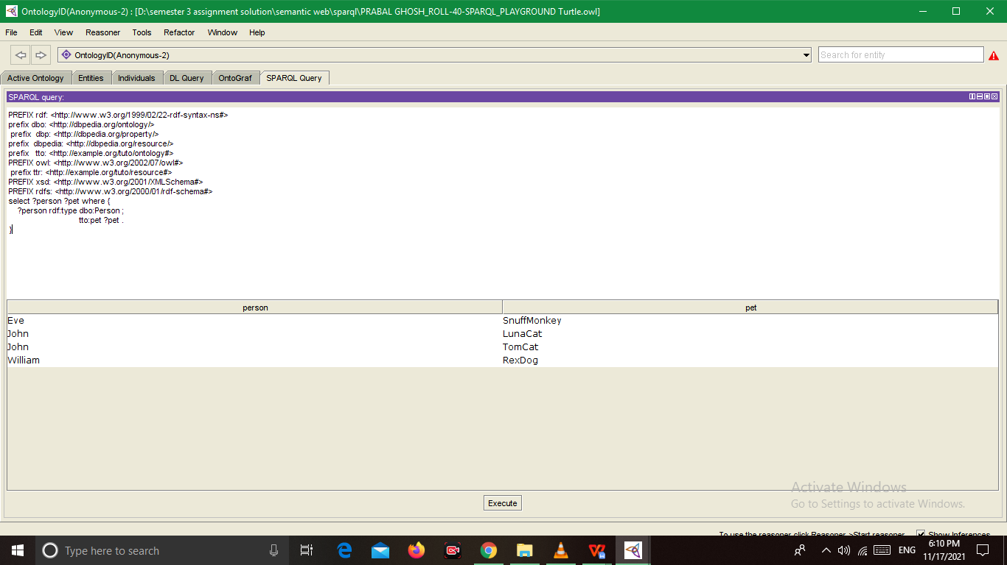

207)

select ?person ?pet where {

?person rdf:type dbo:Person .

optional {?person tto:pet ?pet }.

}

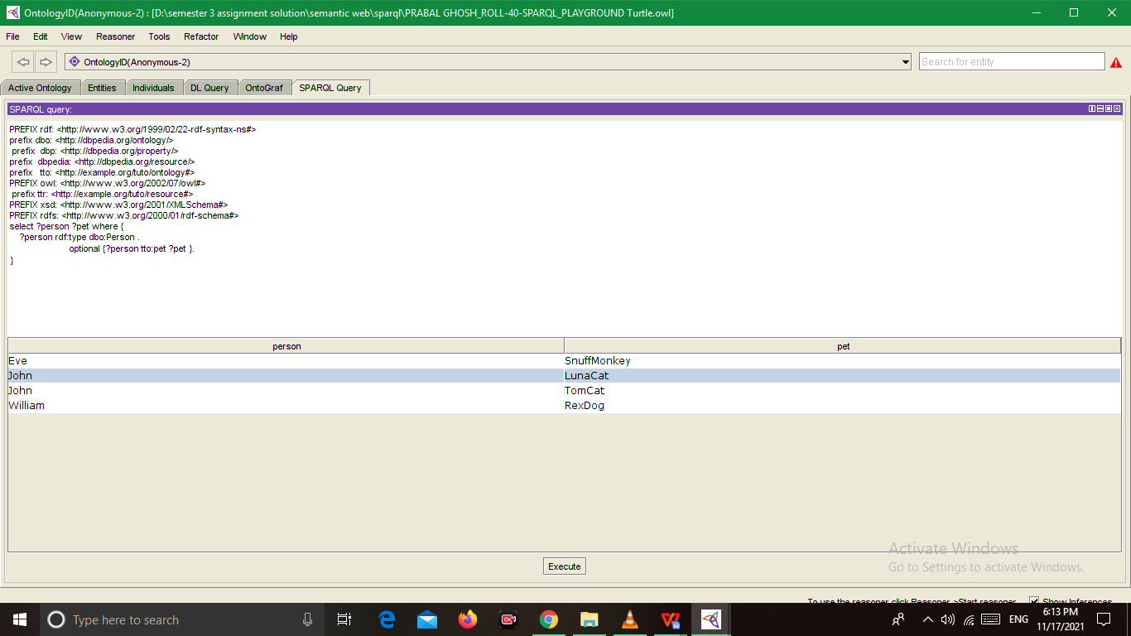

208)

select ?person ?pet where {

?person rdf:type dbo:Person .

filter not exists {?person tto:pet ?pet }.

}

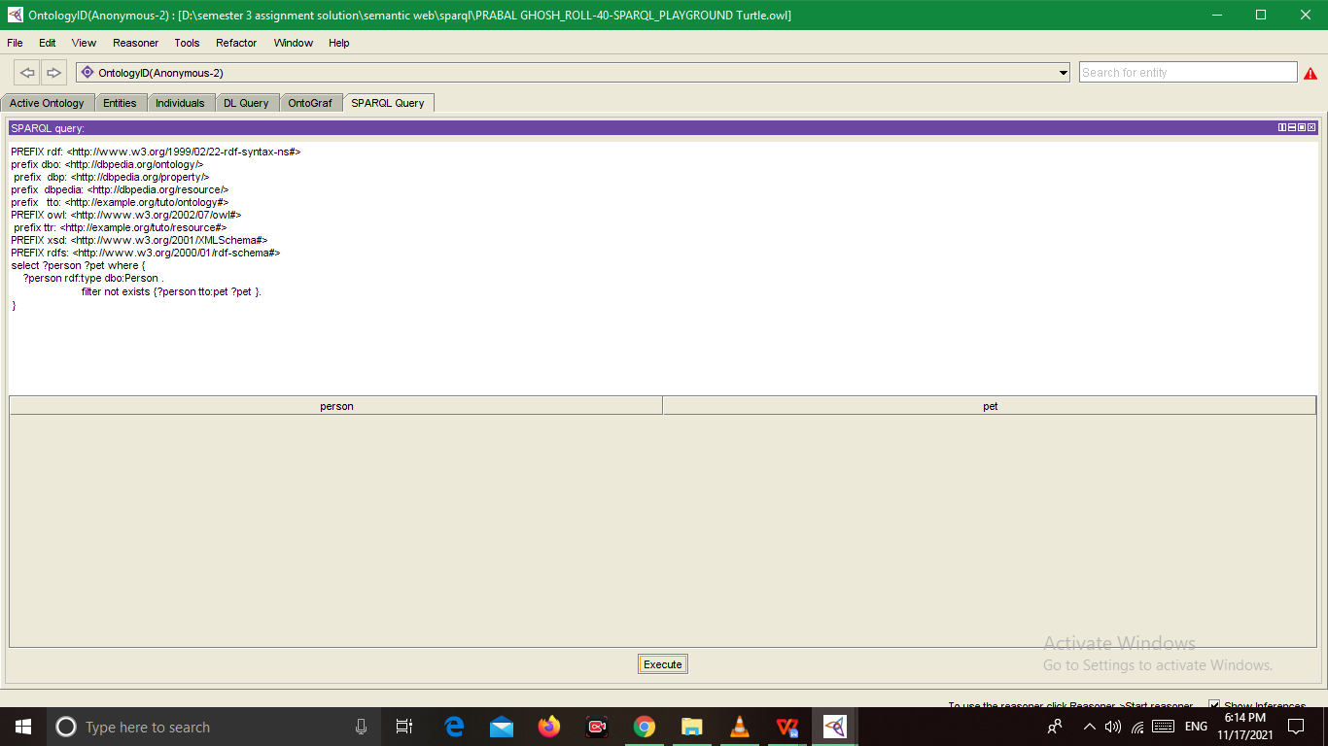

208)

select ( COUNT(?person) AS ?person ) where {

?person rdf:type dbo:Person .

filter not exists {?person tto:pet ?pet }.

}

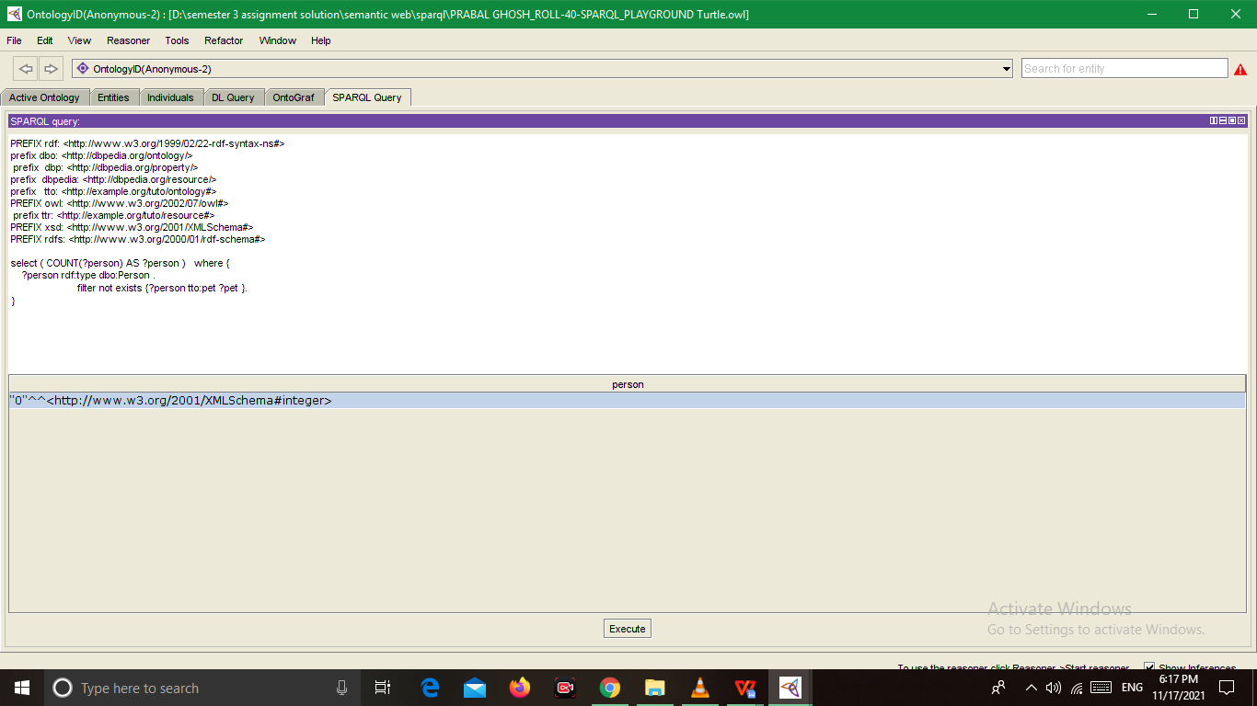

209)

select ?pet where {

{

ttr:William tto:pet ?pet .

} UNION {

ttr:John tto:pet ?pet .

}

}

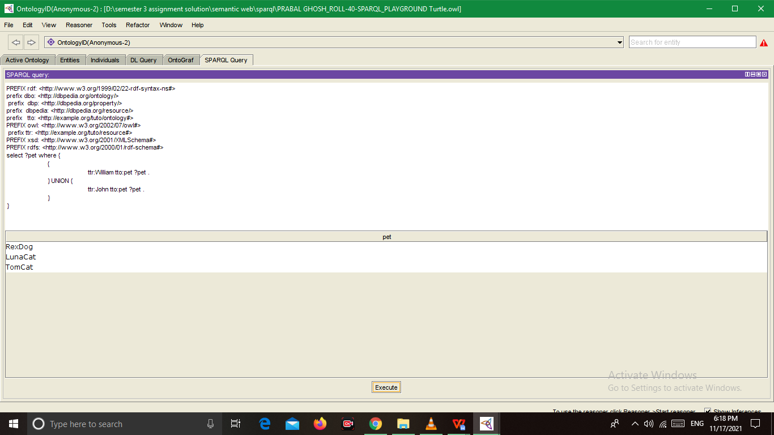

2) Write a SPARQL statement to find out: How many triplets are contained in the

dataset? Take a screenshot of the SPARQL code box and the output and paste in the

word file.

SELECT ( COUNT( ?S) AS ?S)

WHERE { ?S ?O ?P .}

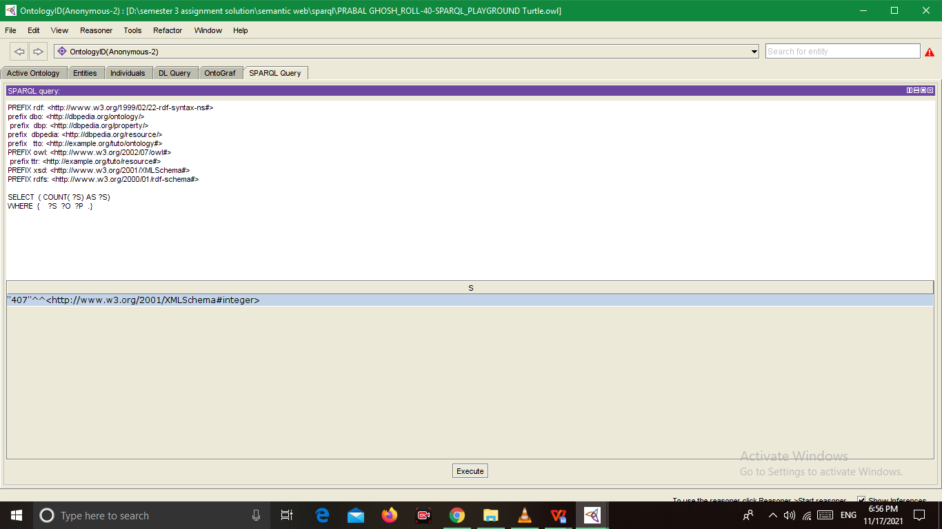

triplets are contained in the

Dataset ------

SELECT ?S ?O ?P

WHERE { ?S ?O ?P .}

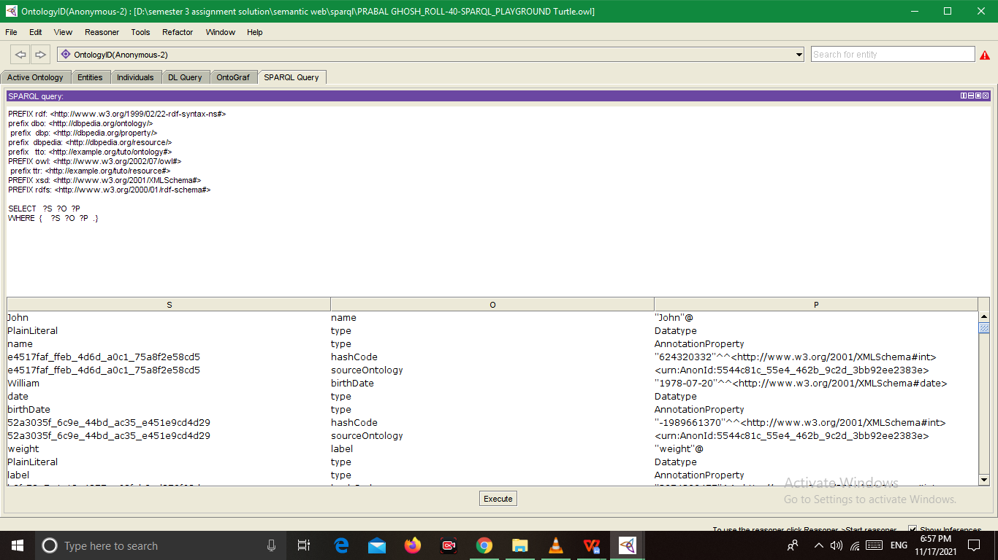

3.

Write a SPARQL statement to find out: How many instances of a “Animal” class are

declared? Take a screenshot of the SPARQL code box and the output and paste

below.

select ?x

where{

{?x rdf:type tto:Cat .

}

UNION

{ ?x rdf:type tto:Monkey.

}

UNION {?x rdf:type tto:Dog.

} }

